TAIYE SMART CNC LATHE FOR EXTRUSION DIES
杭州台业（傻瓜）智能车床
挤压模具

使用说明书
user's manual

TY-6150B

TAIYE－HANGZHOU TAIYE MACHINERY EQUIPMENT CO., LTD
Patent No；ZL 2011 2 0033351.4
Tel: 0571-85146153

Taiye CNC lathe Special features for aluminum extrusion die:
铝型材挤压模具专用数控车床特点：
1，无需编程。我公司提供了自主研发的专业自动编程软件。
2，无需车工知识。简单易学，用工门槛超低不再为招工而烦恼。
3，工作效率高。一个人可轻松操作两台，不用停机可在多页面屏幕下进行后续工件的数据输入。￠180及以下模具月产能1200—1300套。大大降低了车工劳动强度同时也降低了用工成本，半封闭的防护钣金也改善了车工的精神面貌。
4，尺寸精确外形美观均已超过出口标准，且相同模具可实现止口通配。
5，性价比极高。针对铝型材挤压模具专门设计开发，专业性极强，且配件均采用与加工中心同等档次的配置。
6，兴顺精密模具有限公司、广东坚美铝业、广东凤铝铝业、增城荣阳铝业等一大批铝材模具知名企业均已使用且获得非常高的评价。

非常感谢您选用了本公司生产的 TY-6150B 系列数控系统，为简化编程，降低对机床操作人员的技术要求，本机床采用直接图纸数据输入，可大幅提高效率，彻底杜绝编程错误，本说明书详细介绍了图纸数据输入，各功能的特点，注意事项和方法，并配以大量典型编程实例和图例加以说明。
在使用本产品前，请先仔细阅读本说明书，以达到最佳使用效果。

1, No programming is required. Our company provides self-developed professional automatic programming software.
2, No knowledge of operator is required. It is easy to learn, and the use of the workmanship is no longer annoying for recruitment.
3, High-efficiency. One person can easily operate two units, and can input date of subsequent work pieces,under,multi-page screen without shutdown,monthly production capacity of ¢180 and below mould is 1200-1300 sets. It greatly reduce the labor intensity, and labor cost of the operator. The semi-closed protective sheet metal also improves the mental outlook of the lathe.
4, The size and accuracy of the appearance have exceeded the export standard, and the same mold can achieve the mouth wild.
5, the price is extremely high. Specially designed and developed for aluminum extrusion dies, the professionalism is extremely strong, and the accessories are all in the same grade as the machining center.
6, a large of well-known aluminum molds and other well-known enterprises such as GUMEI aluminum company., Guangdong JMA Aluminum company,PT Aluprima pacific industries , etc. have been used our machine and received very high evaluation.
Thank you very much for choosing the TY-6150B series CNC system produced by our company. In order to simplify the programming and reduce the technical requirements for machine operators, this machine adopts direct drawing data input, which can greatly improve the efficiency and completely eliminate programming errors. The paper introduces the input of drawing data, the characteristics of each function, the precautions and methods, and is illustrated with a large number of typical programming examples and legends.

数控车床配置
CNC lathe Configuration
name名称 | Taiye CNC Lathe 6150B
最大回转直径Max. Swing Diameter: | 500mm
最大加工直径Max. processing length(mm) | 1000/1500/1600(optional)
原产地Place of Origin: | Zhejiang, China (Mainland)
电压 Voltage: | Customer's Requirement
功率Power(W): | 7.5kw
机床尺寸Dimension(L*W*H): | 2500*1150*1600mm
重量Weight: | 2500kg
售后服务After-sales Service Provided: | E ngineers available to service machinery overseas
最大工件长度max. work piece leng th: | 750/1000/1500/2000mm
主轴锥度spindle taper: | D8
卡盘尺寸chuck size: | C6
棒料通径spindle bore dia. (MM): | Φ82
主轴转速spindle speed range: (rpm/min) | 60-1600 r/min
套筒行程tail stock center travel: | 150mm
尾架套筒锥孔tail stock sleeve taper: | MT5
X/Z轴快速移动速度 rapid traverse: | 4/6 m/min
X轴行程X-axis max. travel | 285
定位精度Positioning accuracy | 0.015
重复定位精度Repositioning accuracy | ±0.004
工件加工精度  Workpieces processing accuracy | IT6--IT7
加工锥度Processing ellipticity | 0.01
刀具编号Cutter position numbers | 4-6
Standard configurations | Optional configurations
CNC system: | Fanuc/Siemens808D/KND1000TI cnc controller system
Frequency conversion stepless speed regulation | Hydraulic chuck or Pneumatic chuck
Single spindle | Hydraulic tailstock or Pneumatic tailstock
Manual 3-jaw chuck, manual tailstock | Soft jaws/ 4 jaw chuck
4-position electrical tool post | 6/8-station electric tool turret
spindle motor Power: | 7.5kw

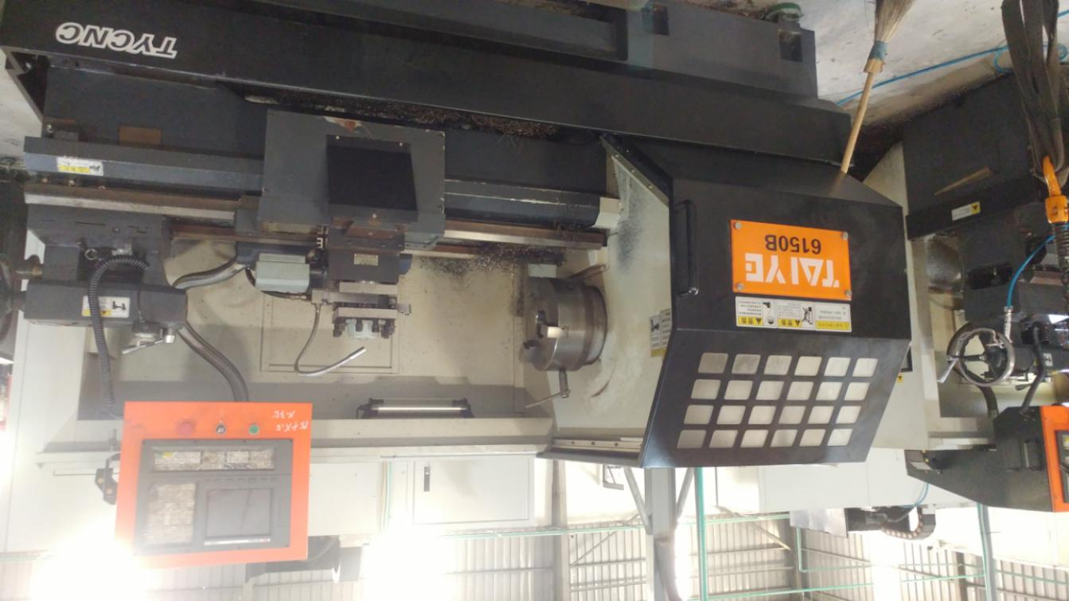
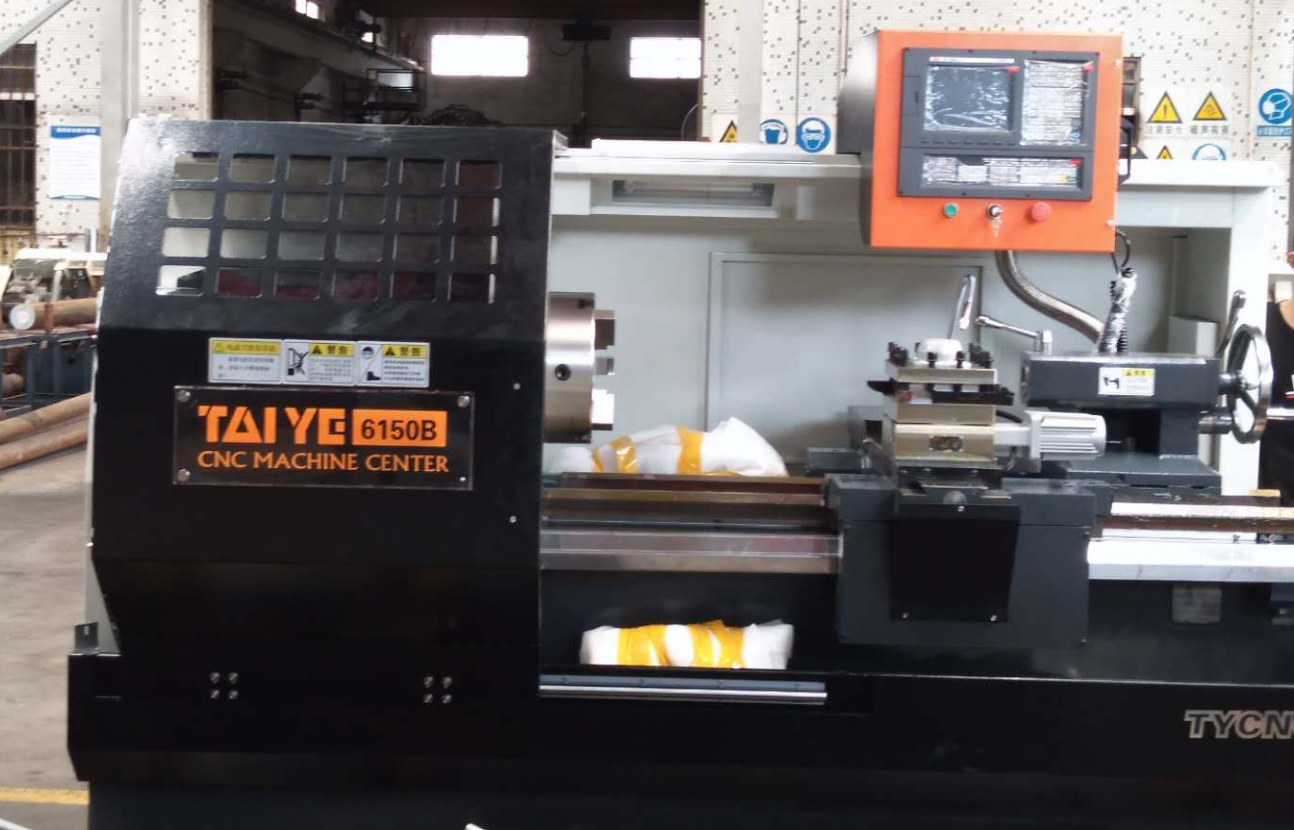
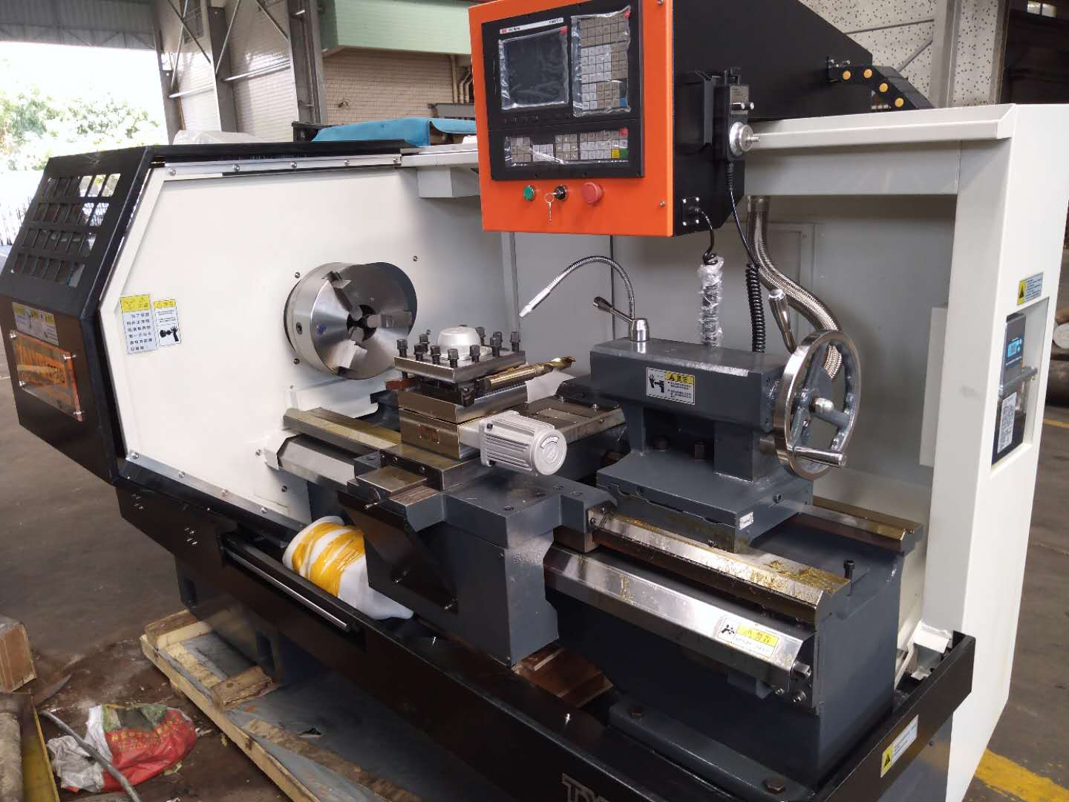

Chapter 1 Rough machining
第一章 粗车加工实例

- 圆钢上模加工输入方法以下图为例
The input method of mold processing on round steel is shown in the following figure.
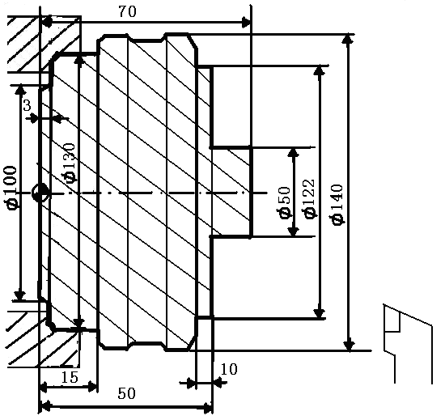
按上图实例‘圆钢上模加工’数据输入如下；
According to the above example, the 'round steel upper mold processing' data is input as follows;
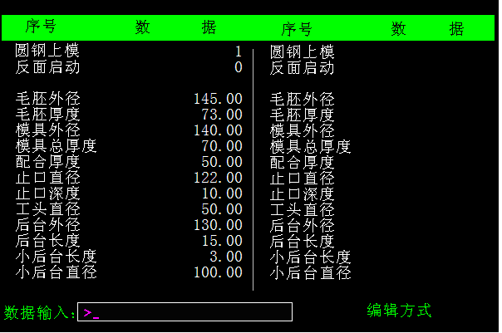
主要参数说明。
1，圆钢上模: 加工有效选择，为0时不加工，为1表示选择加工。
2，反面启动: 反面启动加工有效选择，为0时不加工，为1表示选择反面加工。
3，注意: 不加工的台阶只需长度尺寸输入为零。
The main parameters.
1，Round steel upper die; effective machining selection, no processing when 0, 1 means machining.
2，The reverse side starts; the reverse side starts the machining effective selection, when it is 0, it is not processed, and 1 means the reverse processing is selected.
3，Note; the unprocessed step only needs to enter the length dimension as 0.

- 锻件上模先加工后台输入方法以下图为例。
Forgings first processing the upper mold processing input method The following figure is a column.
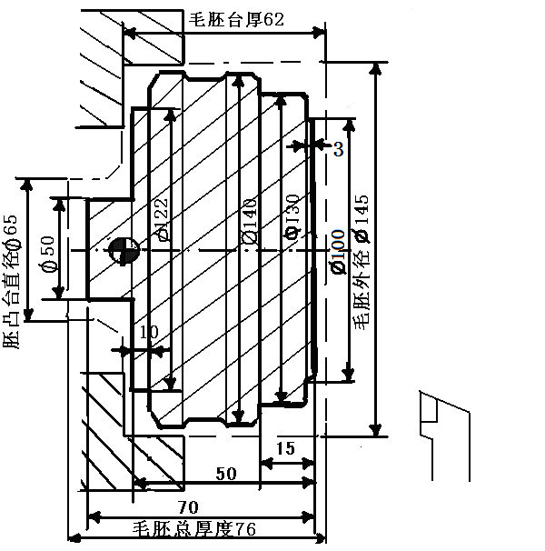
按上图实例‘锻先车后台’数据输入如；
According to the above example data input, such as;
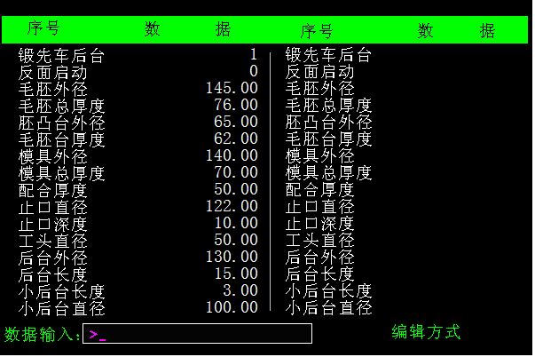
主要参数说明。
1，锻先车后台: 加工有效选择，为0时不加工，为1表示选择加工。
2，反面启动: 反面启动加工有效选择，为0时不加工，为1表示选
3，注意: 不加工的台阶只需长度尺寸输入为零。
forging first turning after; processing effective selection, 0 for no processing, 1 for processing.
the reverse side starts; the reverse side starts the machining effective selection, when it is 0, it is not processed, and the 1 is selected.
note; the unprocessed step only needs to enter 0 for the length dimension.

3. 粗车下模加工输入方法以下图为例
The roughing die machining input method is shown in the following figure.
- 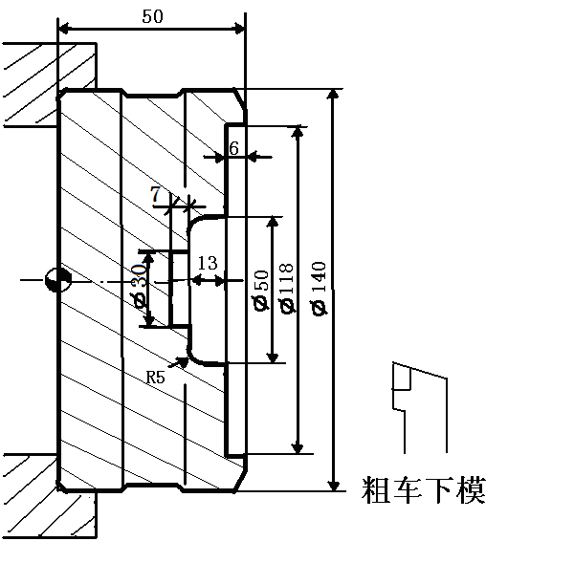
按上图实例‘粗车下模’数据输入如下；
According to the above example, the data of “rough turning die” is input as follows;
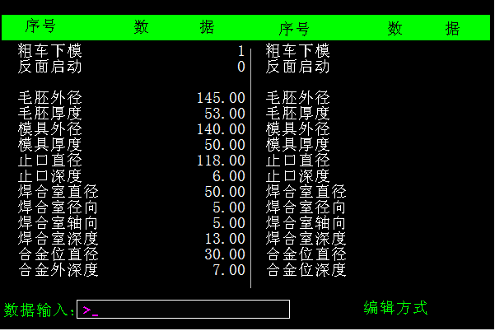
主要参数说明，
1，焊合室径向与焊合室轴向相等，并且等于零加工直角焊合室。
2，焊合室径向与焊合室轴向相等，并且不等于零加工圆角焊合室。
3，焊合室径向与焊合室轴向不相等，并且不等于零加工锥度焊合室。
4，注意: 不加工的台阶只需长度尺寸输入为零。,
Description of main parameters,
1. The welding chamber has a radial direction equal to the axial direction of the welding chamber and is equal to zero machining right angle welding chamber.
2, the weld chamber radial direction is equal to the weld chamber axial direction, and is not equal to zero machining fillet weld chamber.
3. The radial direction of the welding chamber is not equal to the axial direction of the welding chamber, and is not equal to the zero-machining welding chamber.
4, note; the unprocessed step only needs to enter 0 for the length dimension.

4. 凹止口平模加工输入方法以下图为例。
Concave die flat die machining input method The following figure is a column.
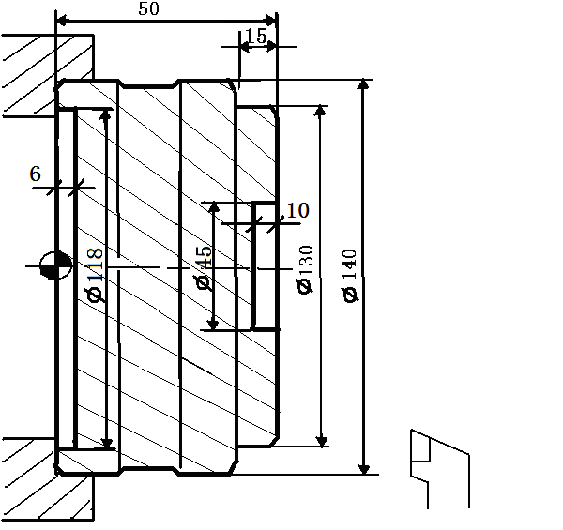

按上图实例‘凹止口平模’数据输入如下；
According to the above example, the 'concave flat die' data is input as follows;
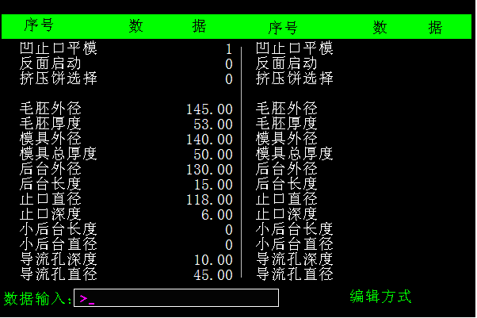

主要参数说明，
注意；不加工的台阶只需长度尺寸输入为零。
Note that the unprocessed step only requires a length dimension of 0.

5. 凸止口下模加工输入方法以下图为例
The method of inputting the convex die lower die processing is shown in the following figure. 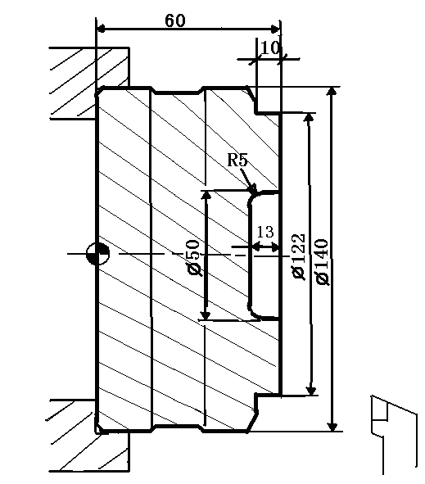
按上图实例‘凸止口下模’数据输入如下；
According to the example above, the ‘bulk stop lower die’ data is input as follows;
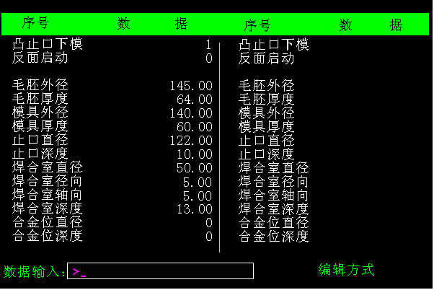

主要参数说明，
1，焊合室径向与焊合室轴向相等，并且等于零加工直角焊合室。
2，焊合室径向与焊合室轴向相等，并且不等于零加工圆角焊合室。
3，焊合室径向与焊合室轴向不相等，并且不等于零加工锥度焊合室。
4，注意；不加工的台阶只需长度尺寸输入为零。
Description of main parameters,
1. The welding chamber has a radial direction equal to the axial direction of the welding chamber and is equal to zero machining right angle welding chamber.
2, the weld chamber radial direction is equal to the weld chamber axial direction, and is not equal to zero machining fillet weld chamber.
3. The radial direction of the welding chamber is not equal to the axial direction of the welding chamber, and is not equal to the zero-machining welding chamber.
4, note; the unprocessed step only needs to enter 0 for the length dimension.

6.只加工孔输入方法以下图为例
Only the hole input method is shown in the following figure.
按上图实例‘只加工孔’数据输入如下
According to the above example, the 'Processing Hole Only' data is entered as follows;
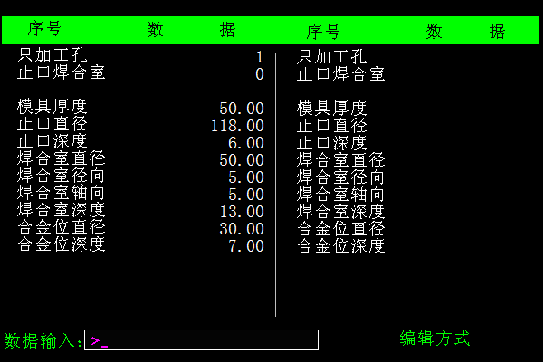
主要参数说明，
注意；不加工的台阶只需长度尺寸输入为零。
Note that the unprocessed step only requires a length dimension of 0.

- 锻件上模先车凸台输入方法以下图为例。
The forging first turning boss input method is shown in the following figure.
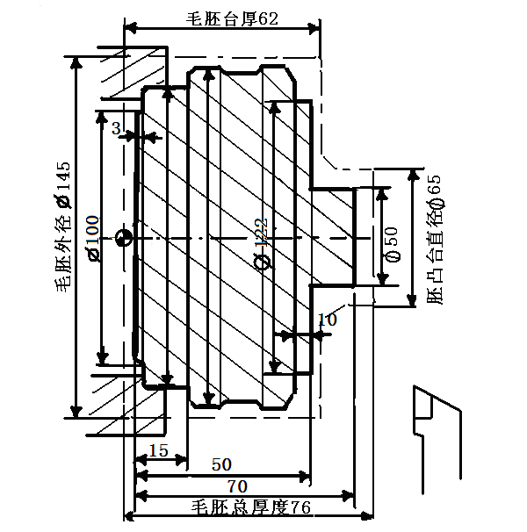

按上图实例‘锻先车凸台’数据输入如下
According to the above example, the data is input as follows;
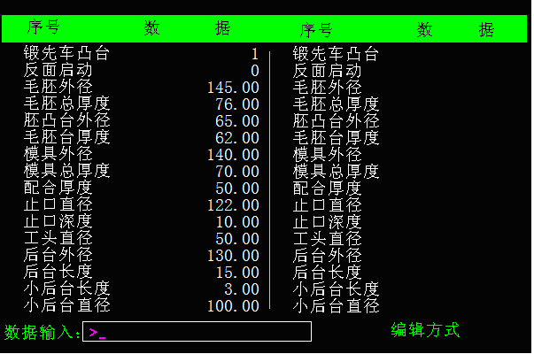

注意；不加工的台阶只需长度尺寸输入为零。
Note that the unprocessed step only requires a length dimension of 0.

- 车模套外型输入方法以下图为例
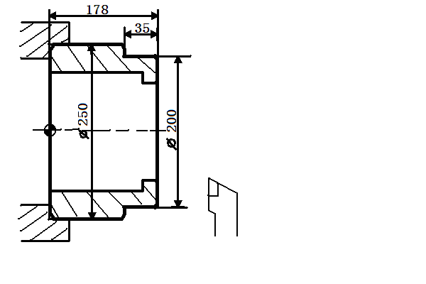
The input method of the turning die set is shown in the following figure.

按上图实例‘车模套外型’数据输入如下
According to the above example, the data is input as follows;
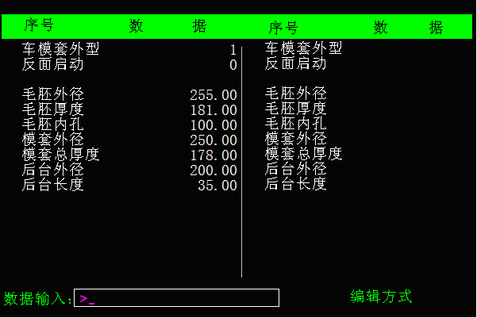

- 车模套内孔输入方法以下图为例

The method of inputting the inner hole of the turning die sleeve is shown in the following figure.
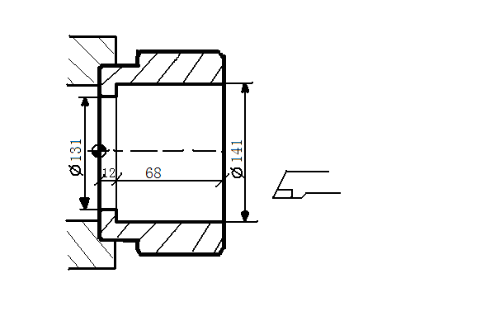

按上图实例‘车模套内孔’数据输入如下
According to the above example, the data is input as follows;
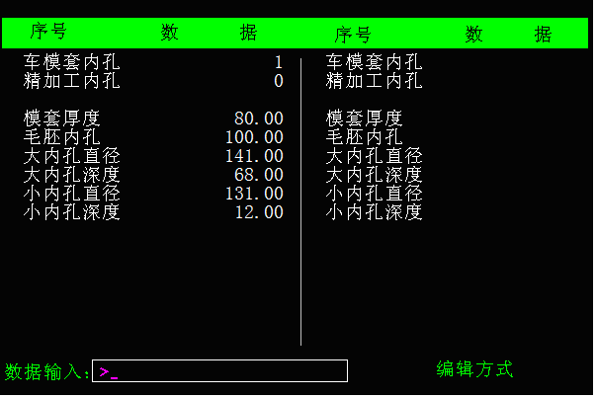

- 只加工台阶输入方法以下图为例
Only the step input method is shown in the following figure.
按上图实例‘只加工台阶’数据输入如下
According to the above example, the data of “Processing only steps” is input as follows;
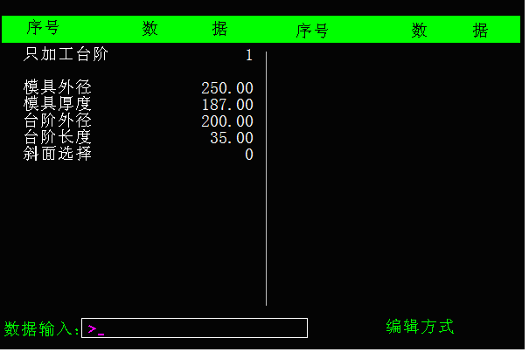
主要参数说明，
斜面选择；当数据为零时加工直台阶，当数据为1时加工斜台阶。
The main parameters,
Bevel selection; when the data is zero, the straight step is processed, and when the data is 1, the oblique step is processed.

第二章 精车加工实列
Chapter II Finishing Machine Processing

- 上模加工输入方法以下图为例
The upper die machining input method is shown in the following figure.
按上图实例‘圆钢上模加工’数据输入如下；
According to the above example, the 'round steel upper mold processing' data is input as follows;
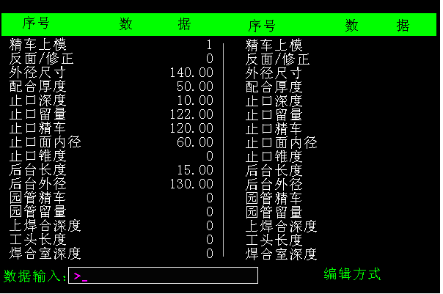

主要参数说明。
- 圆钢上模: 加工有效选择，为0时不加工，为1表示选择加工。
2，反面/修正: 反面启动加工有效选择，为0时不加工，加工暂停下大于0时可修正止口尺寸。
3. 注意:不加工的台阶只需长度尺寸输入为零。
Description of the main parameters.
1, round steel upper die; processing effective selection, when 0 is not processed, 1 means selective processing.
2, the reverse side / correction; the reverse side starts the machining effective selection, when it is 0, it is not processed, and when the machining pause is greater than 0, the size of the stop can be corrected.
3, note; the unprocessed step only needs to enter the length dimension as 0.

- 下模加工输入方法以下图为例
Lower Die Machining Input Method The following figure shows the column.
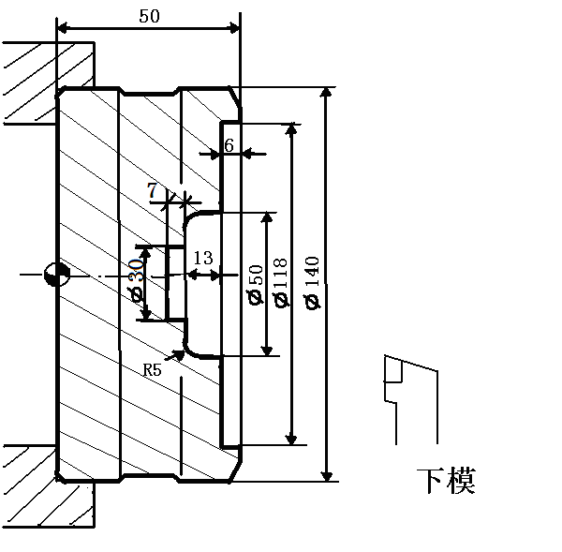
按上图实例‘精车下模’数据输入如下
According to the above example, the data of the 'finishing lower die' is input as follows;
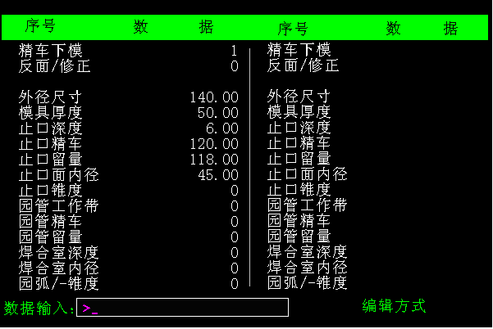
主要参数说明，
1，止口锥度: 选择止口锥度加工。
2，园弧/锥度，选择加工直角焊合室或加工锥度焊合室。
3，园管精车，选择加工园管。
4，注意: 不加工的台阶只需长度尺寸输入为零
Description of main parameters,
1, the taper of the mouth, choose the taper processing of the mouth.
2, circular arc / taper, choose to process right angle welding chamber or processing taper welding chamber.
3, the garden tube finishing, choose the processing garden tube.
4, note; the unprocessed step only needs to enter 0 for the length dimension.

第三章 挤压模具车床对刀方法
Chapter III Extrusion Die Lathe Tooling Method

本机床的人机界面如下；
1．刀具测量，用于直接对刀。
The man-machine interface of this machine is as follows;
- Tool measurement for direct tool setting.
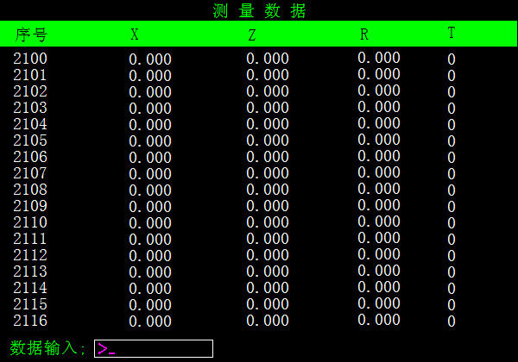
(1)在录入方式下，输入T0101; 换一号刀。
(2)在手轮方式下，移动一号刀具到工件外圆面，将工件外圆尺寸实测值输入2101的X数据位。
(3)在手轮方式下，移动一号刀具到工件端面，将工件厚度尺寸实测值输入2101的Z数据位。
(4)按以上方法依次完成其余刀具测量输入。
(5)X为外径代码，Z为厚度代码。

(1). In the input mode, enter T0101; change the number one knife.
(2). In the handwheel mode, move the No. 1 tool to the outer circular surface of the workpiece, and input the measured value of the outer circle size of the workpiece into the X data position of 2101.
(3). In the handwheel mode, move the No. 1 tool to the end face of the workpiece, and input the measured value of the workpiece thickness dimension into the Z data bit of 2101.
(4). Complete the remaining tool measurement inputs in turn as described above.
(5), X is the outer diameter code, and Z is the thickness code.

2 刀具刀补，用于尺寸修正
tool compensation, for size correction.
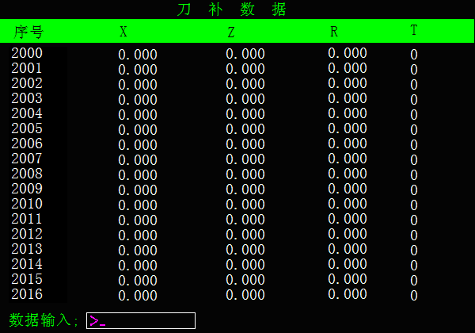
(1)刀补功能主要用于尺寸修正。
(2)根据刀号要加大外圆尺寸，输入U加正的尺寸修正量。
(3)根据刀号要减小外圆尺寸，输入U加负的尺寸修正量。
(4)根据刀号要加厚工件厚度尺寸，输入W加正的尺寸修正量。
(5)根据刀号要减小工件厚度尺寸，输入W加负的尺寸修正量。
(6)2001为一号刀补，2002为二号刀补，依次类推刀补号。
(7)U为外径代码,W为厚度代码。
1, the tool compensation function is mainly used for size correction.
2, according to the size of the knife to increase the size of the outer circle, enter the U plus positive size correction.
3. According to the tool number to reduce the outer circle size, input U plus negative size correction amount.
4, according to the knife number to thicken the workpiece thickness size, input W plus positive size correction.
5, according to the tool number to reduce the thickness of the workpiece, input W plus negative size correction.
6, 2001 for the first knife, 2002 for the second knife, and so on.
7, U is the outer diameter code, and W is the thickness code.

